**Automated S3 Bucket Cleanup Using AWS Lambda and Boto3**

**Objective:**To gain experience with AWS Lambda and Boto3 by creating a Lambda function that will automatically clean up old files in an S3 bucket.

**Task:**Automate the deletion of files older than 30 days in a specific S3 bucket.

**Instructions:**

**1. S3 Setup:**

   - Navigate to the S3 dashboard and create a new bucket.

   - Upload multiple files to this bucket, ensuring that some files are older than 30 days (you may need to adjust your system's date temporarily for this or use old files).

I already have an S3 Set up and don’t want to create new but this can be created easily from S3 Option for AWS Console

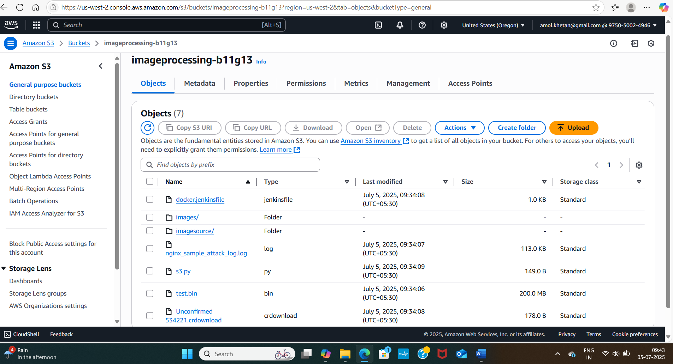

Uploaded few files, laptop OS is not allowing to go to back date and anyways on S3 upload it is picking today’s date only. I will test for 1 day only but final code will have 30days

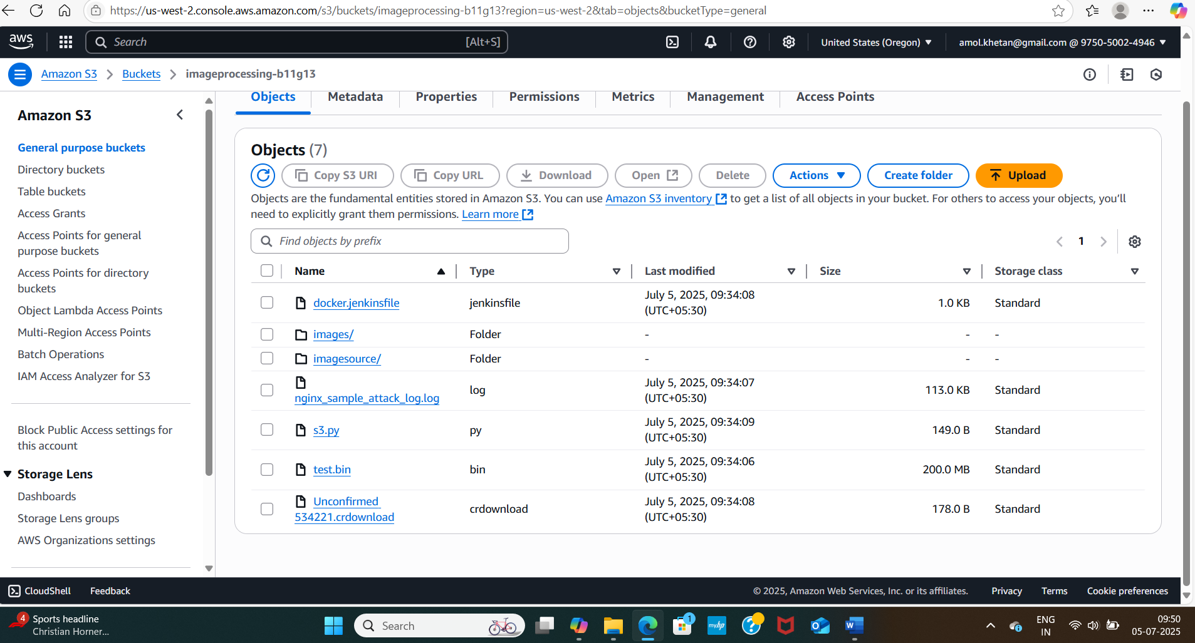

**2. Lambda IAM Role:**

- In the IAM dashboard, create a new role for Lambda.

   - Attach the `AmazonS3FullAccess` policy to this role. (Note: For enhanced security in real-world scenarios, use more restrictive permissions.)

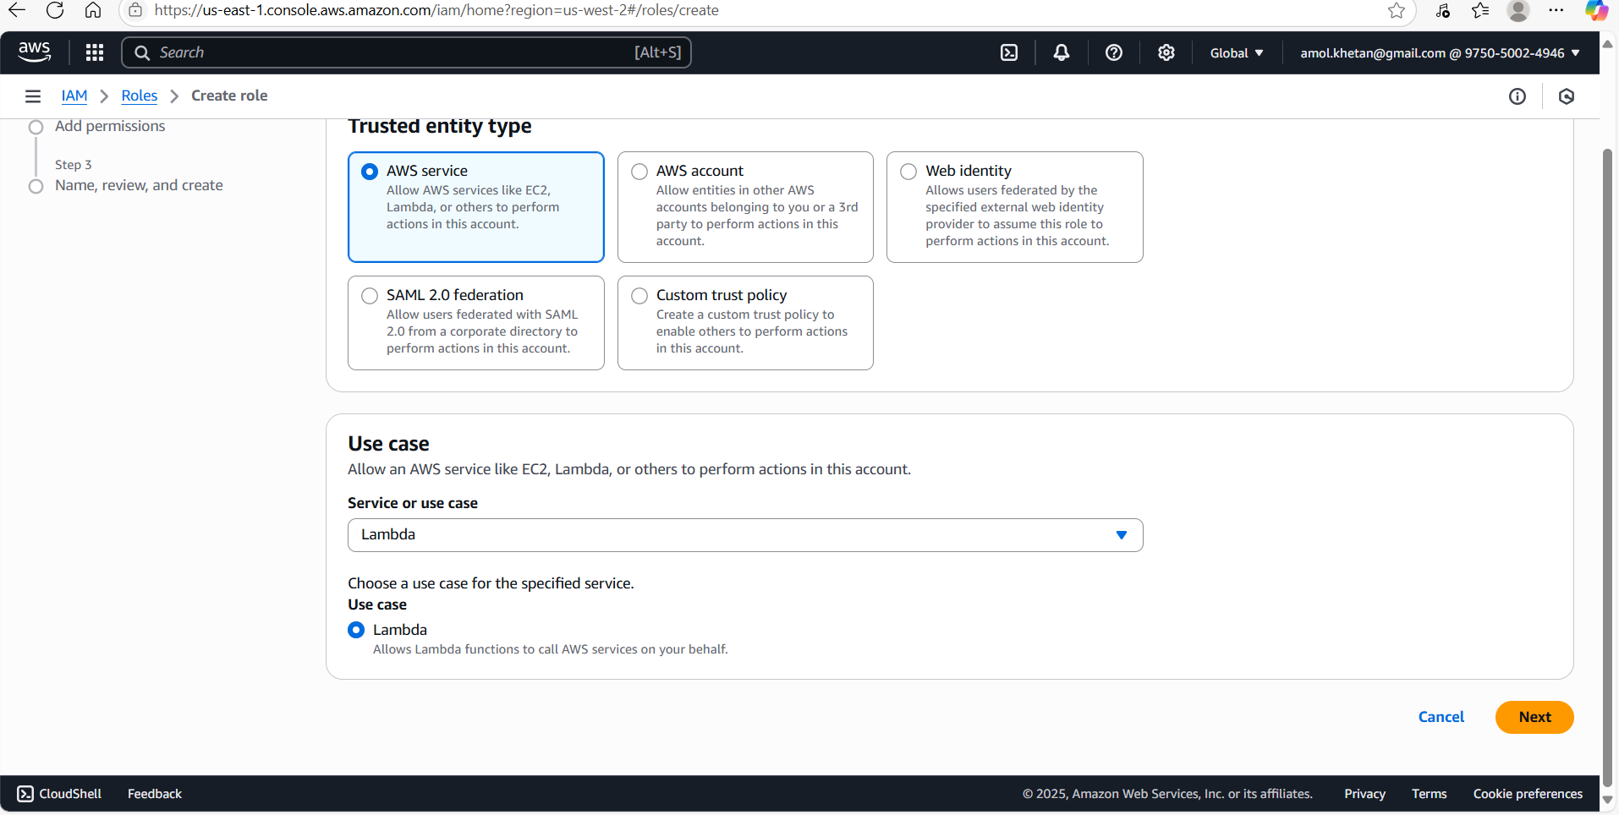

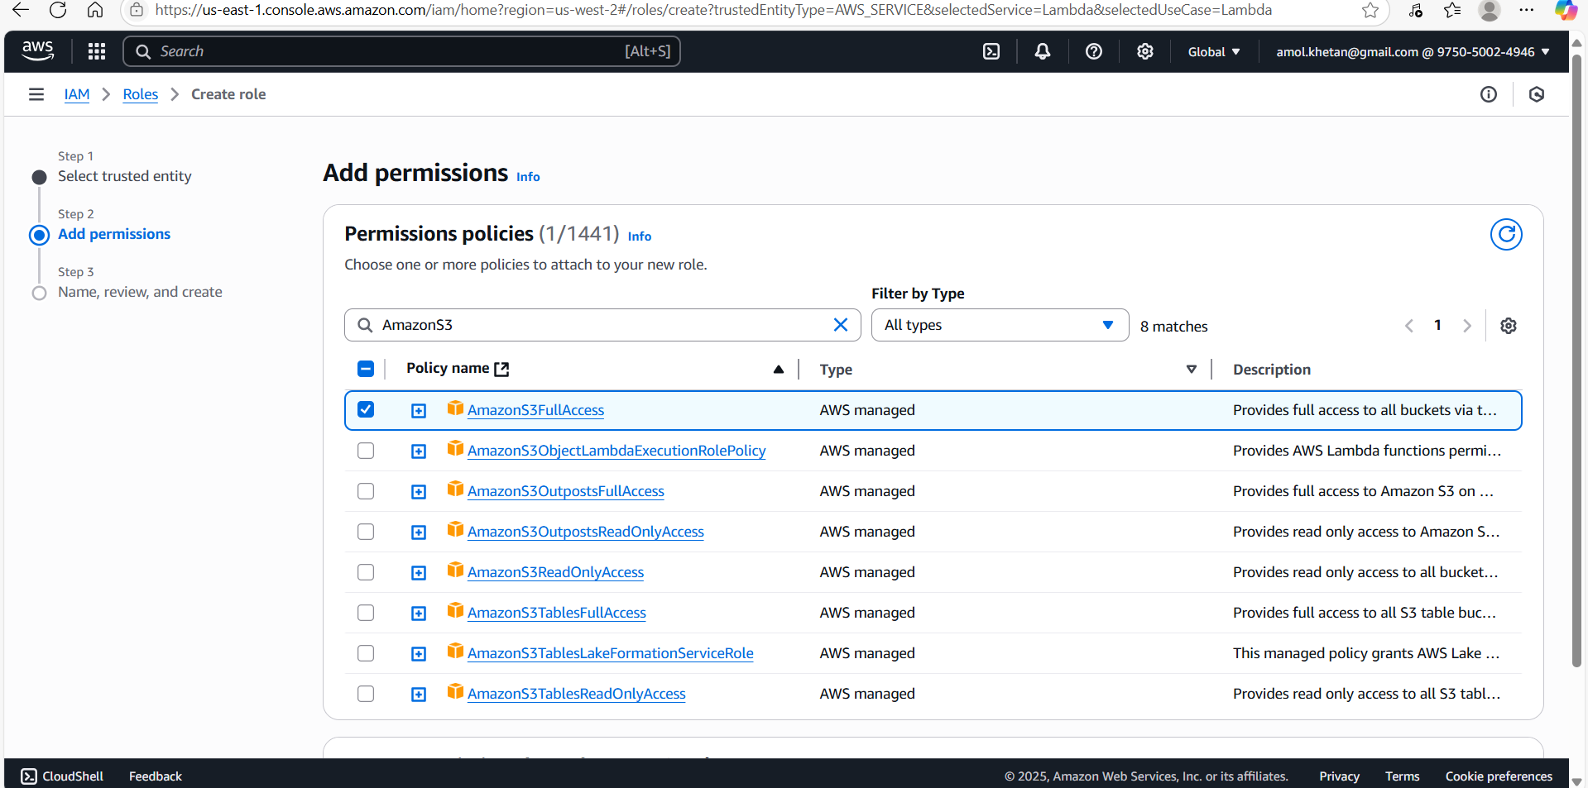

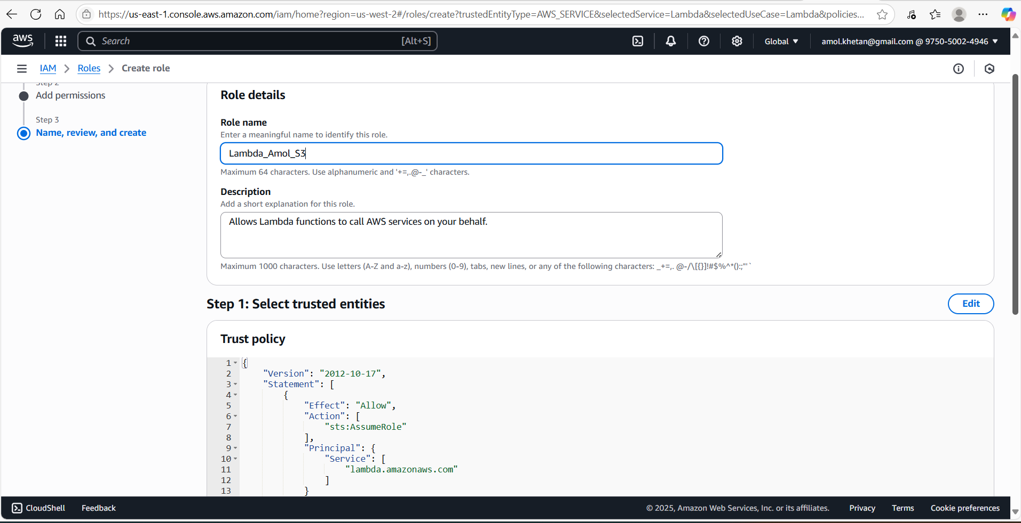

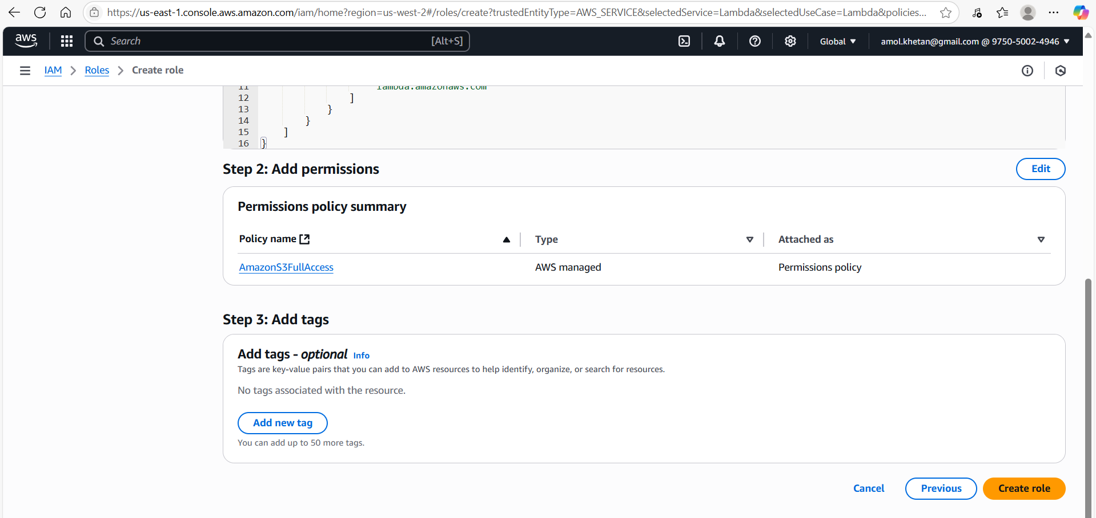

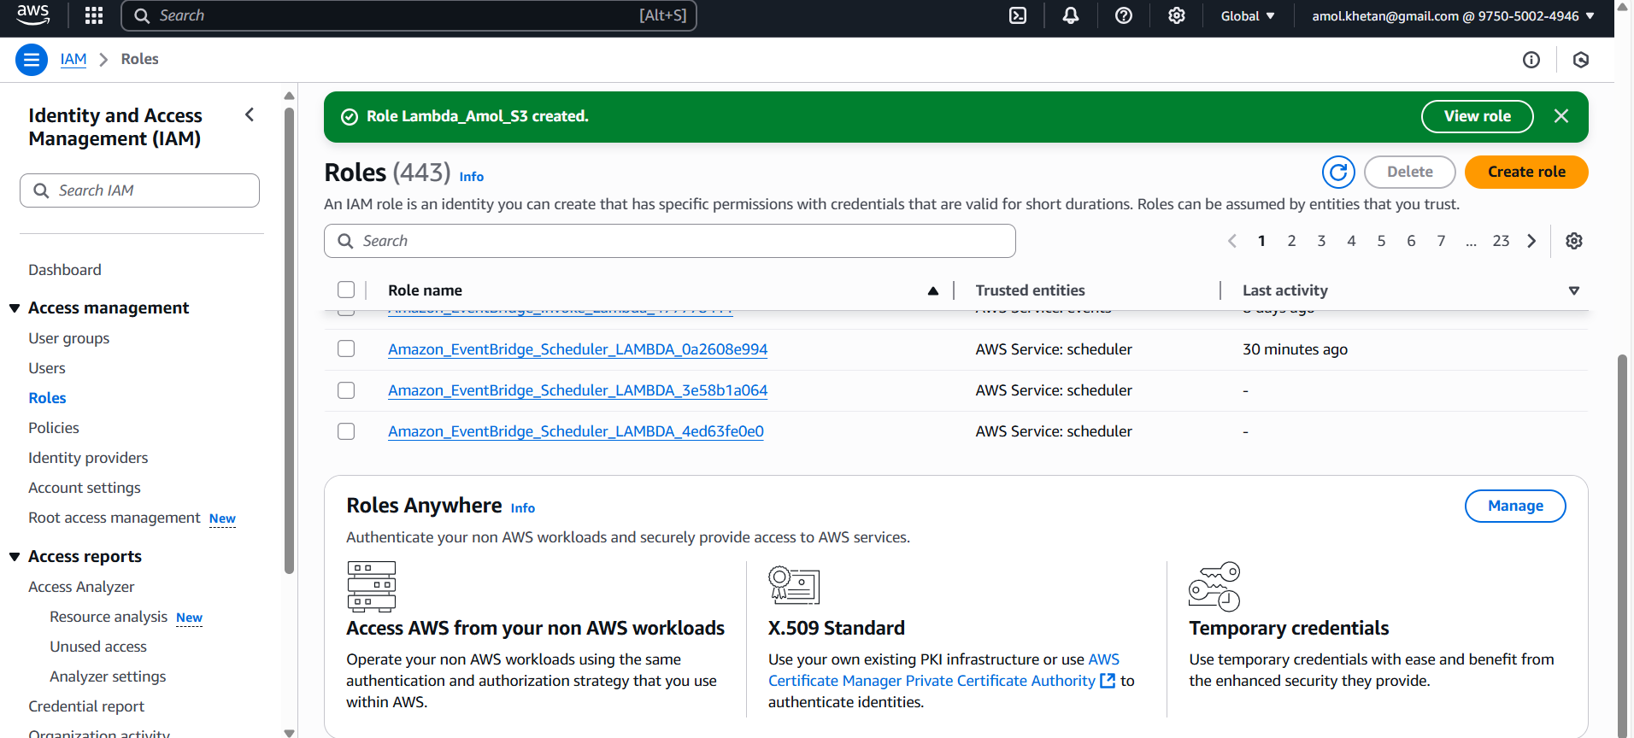

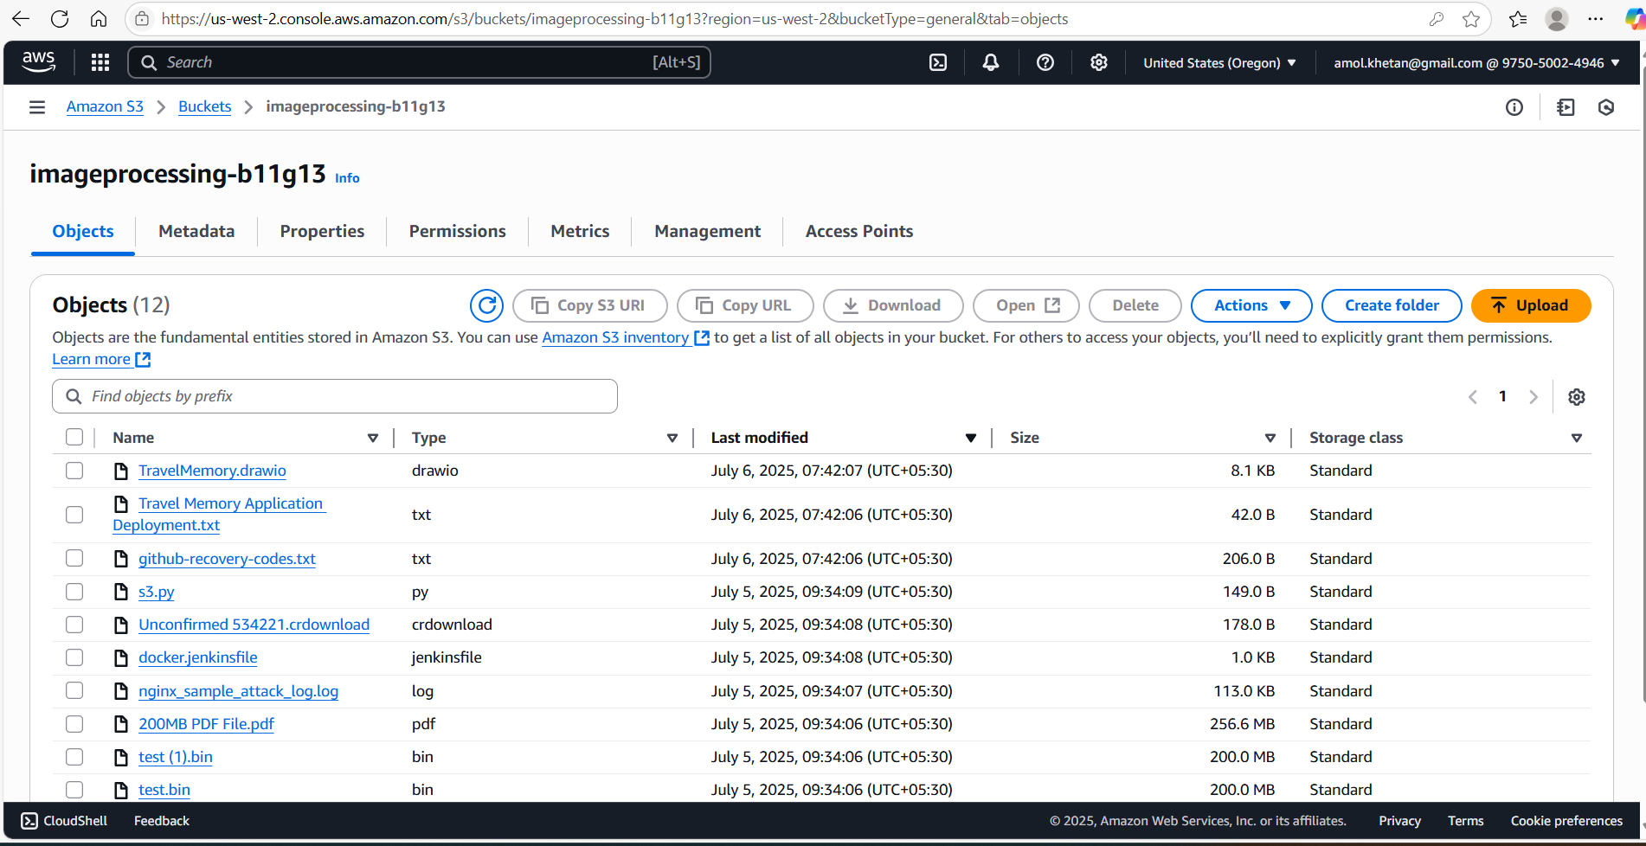

**3. Lambda Function:**

- Navigate to the Lambda dashboard and create a new function.

 - Choose Python 3.x as the runtime.

 - Assign the IAM role created in the previous step.

 - Write the Boto3 Python script to:

     1. Initialize a boto3 S3 client.

     2. List objects in the specified bucket.

     3. Delete objects older than 30 days.

     4. Print the names of deleted objects for logging purposes.

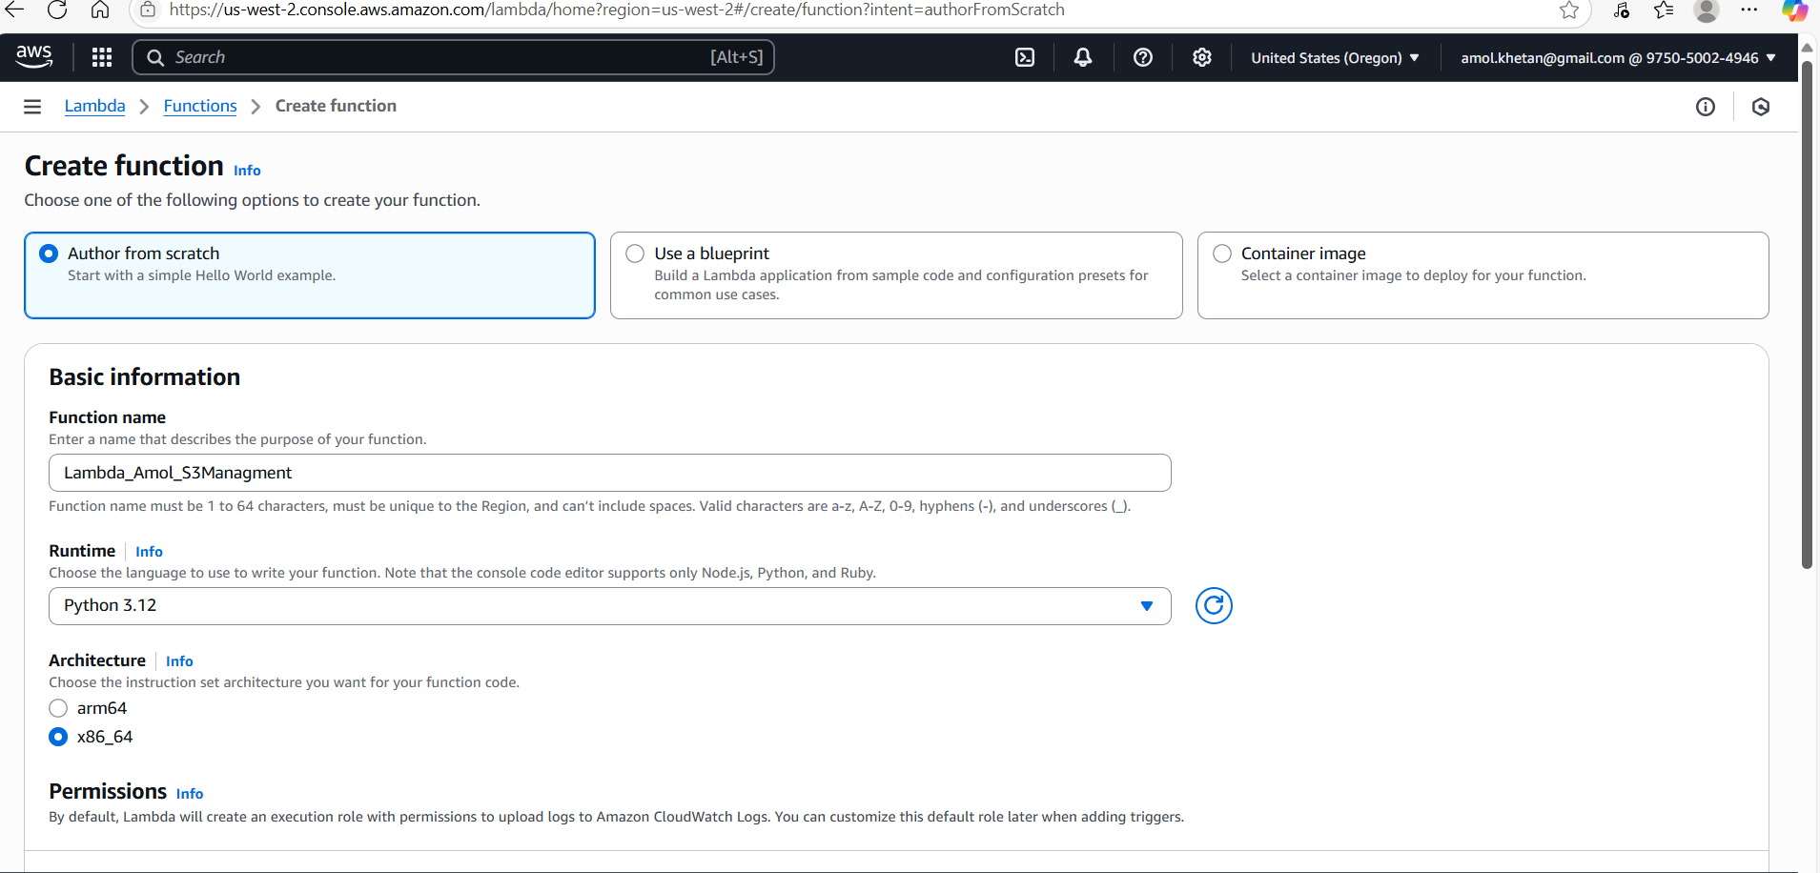

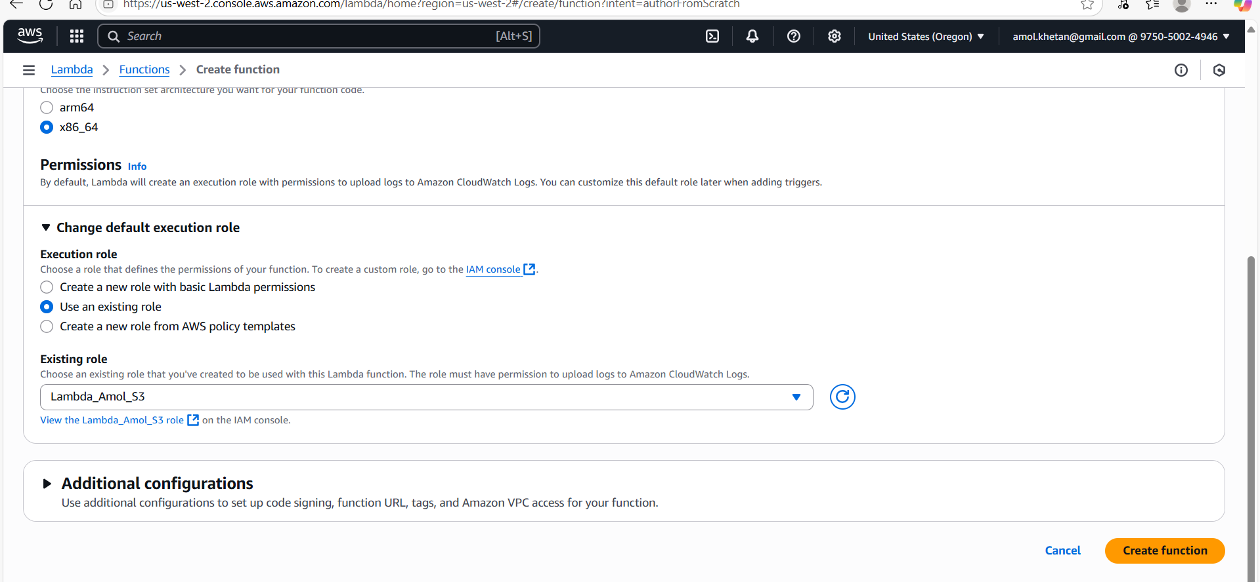

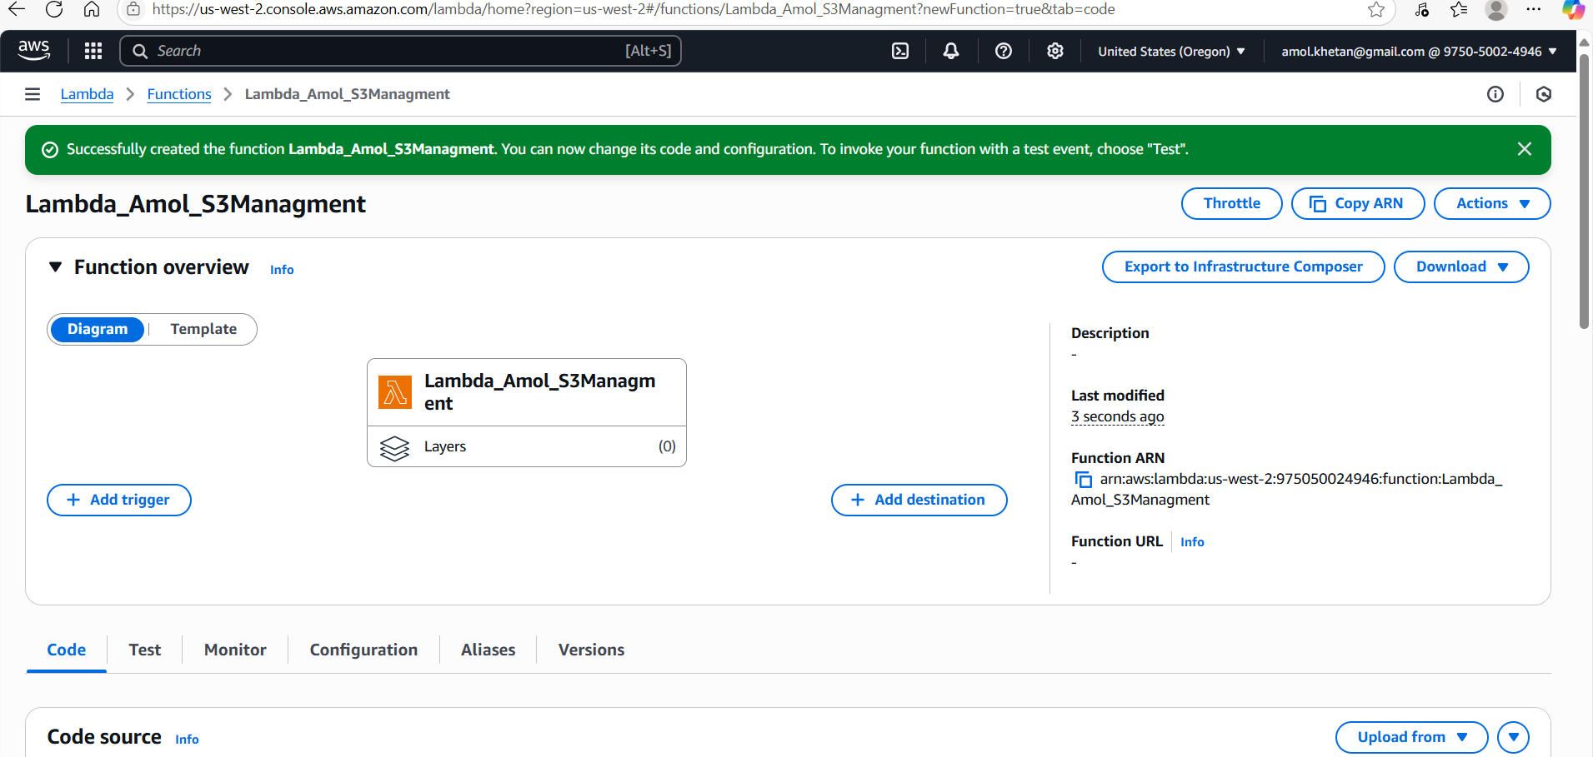

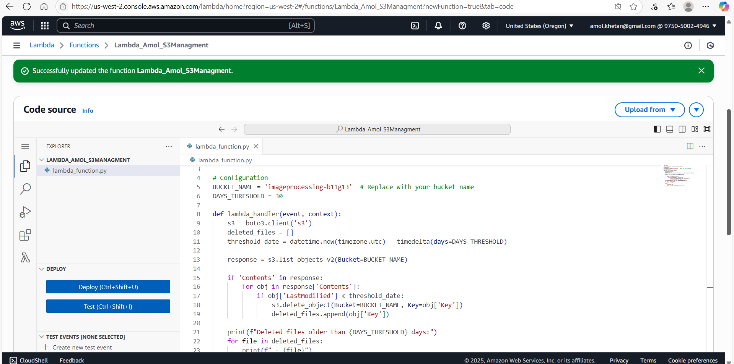

**4. Manual Invocation:**

   - After saving your function, manually trigger it.

   - Go to the S3 dashboard and confirm that only files newer than 30 days remain.

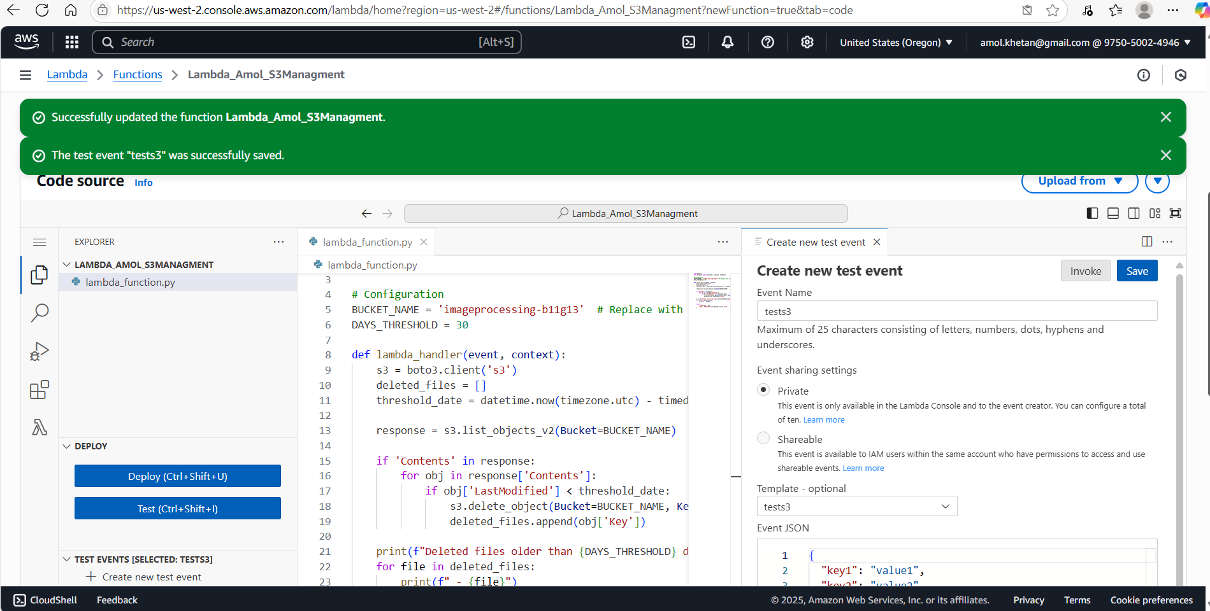

**Zero Files Deleted as Threosold was set to 30 Days. I will retest this tomorrow with threshold as 1 Day. Unable to change system date due to admin access issue.**

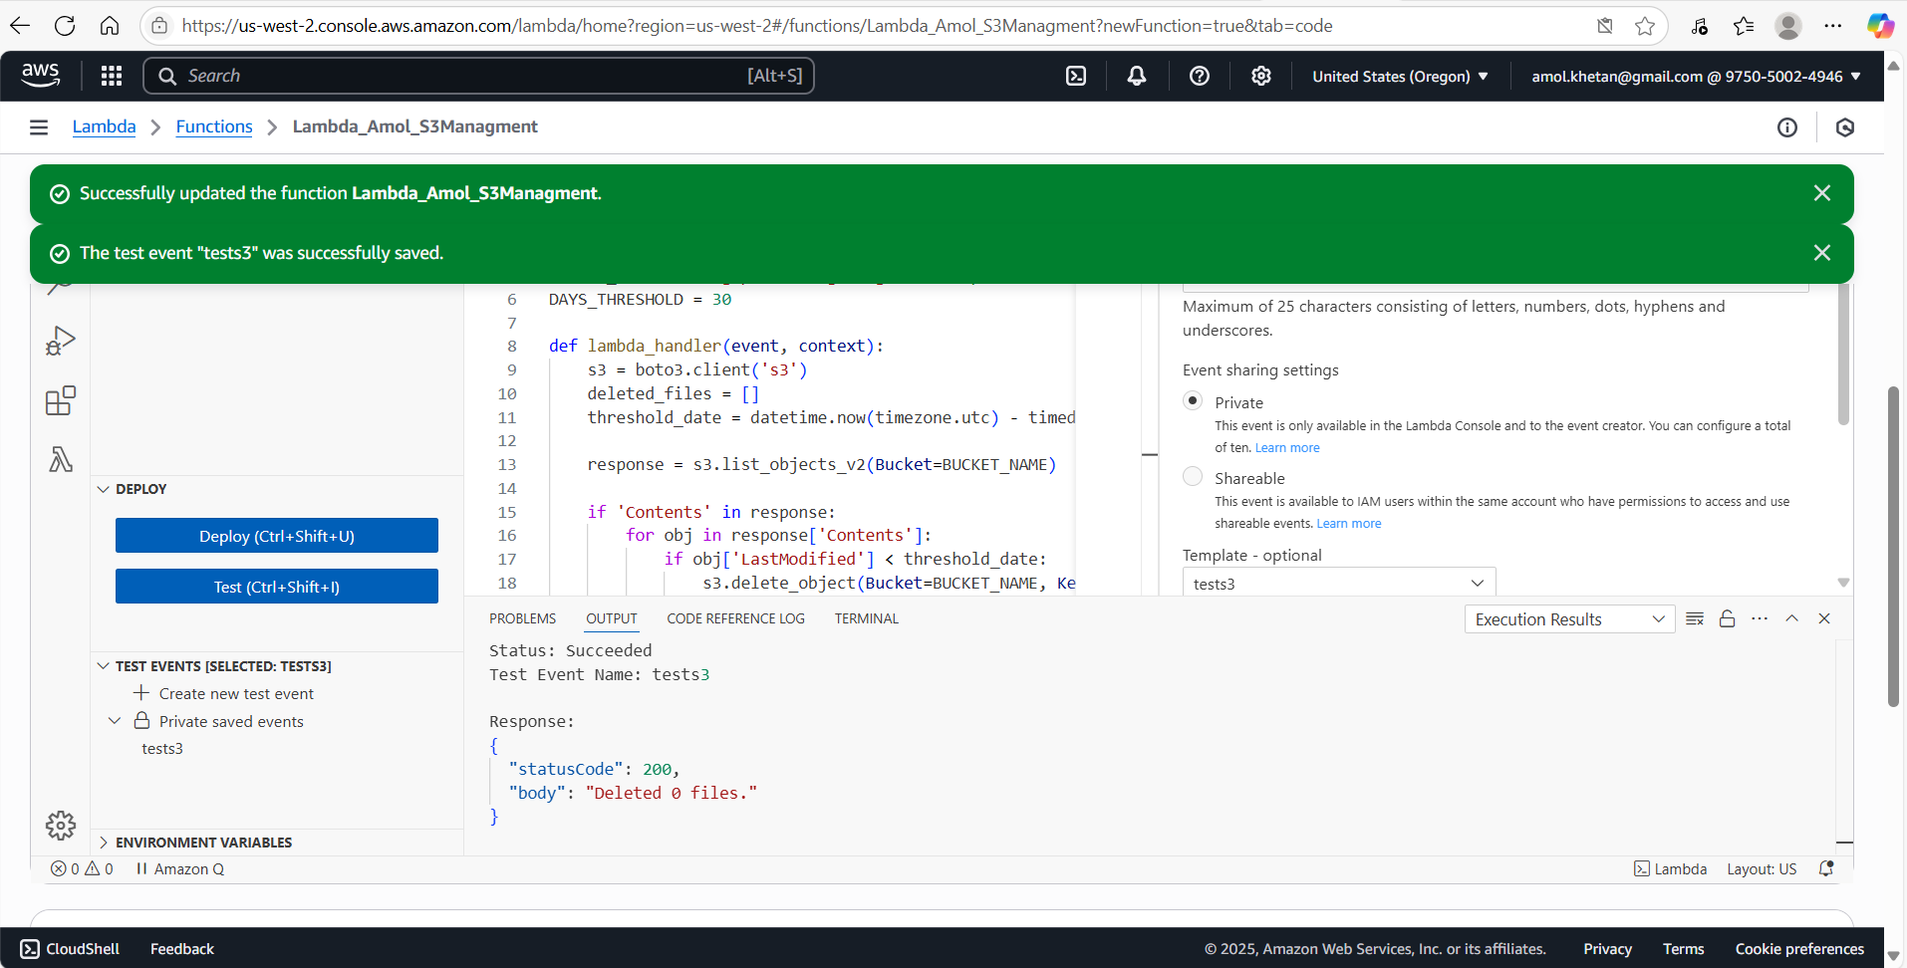

**Lambda Output (Nothing Deleted as there is no file older than 30:**

Status: Succeeded

Test Event Name: tests3

Response:

{

  "statusCode": 200,

  "body": "Deleted 0 files."

}

Function Logs:

START RequestId: 3eb9bf25-549f-4893-8b6c-4222a4a429a8 Version: $LATEST

Deleted files older than 30 days:

END RequestId: 3eb9bf25-549f-4893-8b6c-4222a4a429a8

REPORT RequestId: 3eb9bf25-549f-4893-8b6c-4222a4a429a8  Duration: 3084.44 ms    Billed Duration: 3085 ms    Memory Size: 128 MB Max Memory Used: 88 MB  Init Duration: 401.03 ms

Request ID: 3eb9bf25-549f-4893-8b6c-4222a4a429a8

**Now, change Days_thresold to 1. Deploy and test the code**

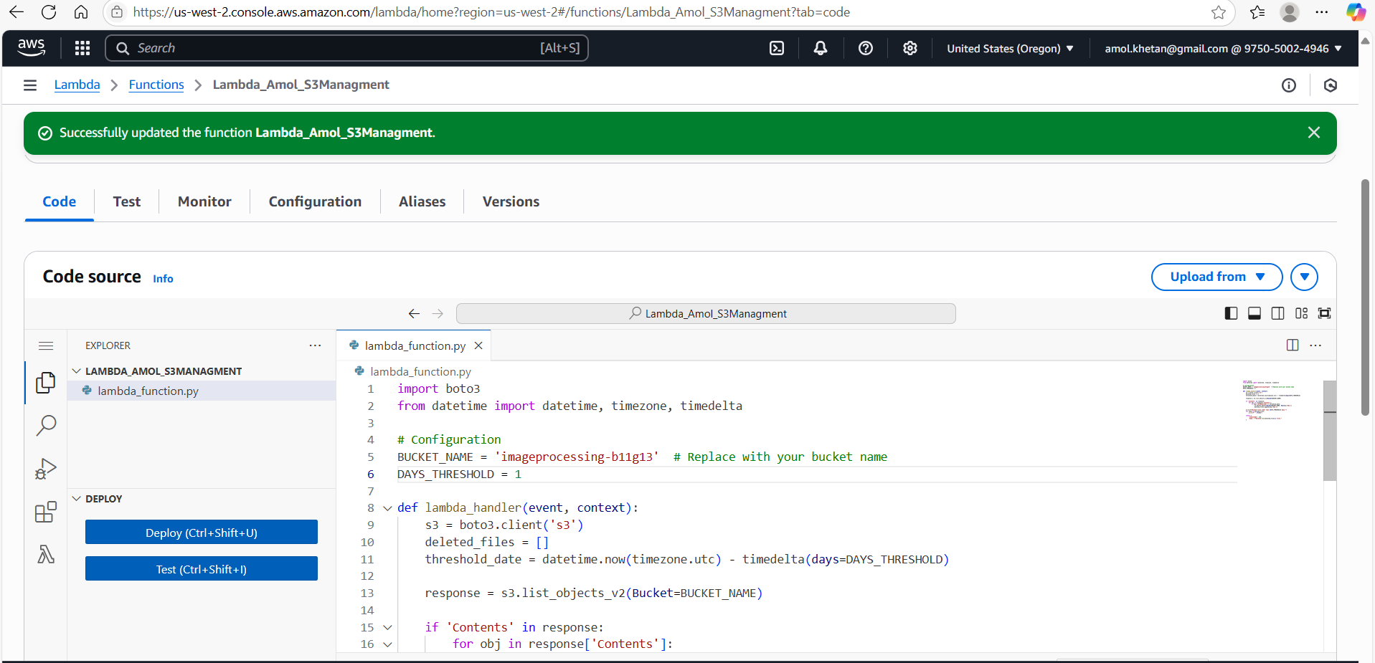

**Lambda Output (files and folders older than 1 days deleted)**

**Now change the Thresold back to 30 Days. Lambda Function Working properly.**

tatus: Succeeded

Test Event Name: tests3

Response:

{

  "statusCode": 200,

  "body": "Deleted 2 files."

}

Function Logs:

START RequestId: a8aca8e5-1ddf-493d-ab60-b3102c02a486 Version: $LATEST

Deleted files older than 1 days:

- images/

- imagesource/

END RequestId: a8aca8e5-1ddf-493d-ab60-b3102c02a486

REPORT RequestId: a8aca8e5-1ddf-493d-ab60-b3102c02a486  Duration: 3205.36 ms    Billed Duration: 3206 ms    Memory Size: 128 MB Max Memory Used: 86 MB  Init Duration: 311.49 ms

Request ID: a8aca8e5-1ddf-493d-ab60-b3102c02a486